Consultancy Findings
Version 1 | 26/09/2025

Grainger plc
Salesforce Data Storage Cleanup

Contents
1. Introduction 3
1.1 Executive Summary 3
1.2 References 3
2. Analysis and recommendations 4
2.1 Current Data usage 4
2.1.1 Email Messages 4
2.1.2 Payments 5
2.1.3 Tenancy Payment Schedules 5
2.1.4 Agreement Notifications 6
2.1.5 Agreement Events 6
2.2 Recommendations 7
2.2.1 Return to Compliance 7
2.2.2 Remaining in Compliance 7
3. Cost and timelines 8
3.1 Return to compliance cost 8

- Introduction
- Executive Summary
Grainger have exceeded their allotted Data Storage allowance within Salesforce and are required to reduce the amount of storage used or purchase more storage from Salesforce. A third option is available where an archiving solution provided by Own could also be purchased if the data is not able to be purged. Grainger requested Open Box to investigate the amount of storage currently being used and offer advice on the suggest next steps.
Salesforce’s recommended solution is Salesforce Archive. The details they have provided show a cost £9 600 per year. Their alternative option is to purchase additional storage at £85 per month per 500MB, the total annually for this option would be £12 240.
The overall recommendation from this consultancy is not spend close to £50 000 over the rest of the contract with Salesforce and instead complete a one-off purge of records that are deemed safe to delete to bring the org back into compliance. Once this has been completed, an automated process should be developed to ensure that there is no longer a risk of a proliferation of excess records.
- References
Adobe Sign for Salesforce: Developer Guide
Adobe Sign for Salesforce: Troubleshooting Guide
- Analysis and recommendations
Open Box attempted to identify records that could be deleted without any loss of on-platform functionality or future potential to be used for analytics and insights. To ensure a healthy degree of caution, all records created within the last 365 days will be retained.
- Current Data usage
Grainger’s current Data Storage usage of 18.6GB is 20% over the limit of 15.6GB. As part of the analysis Open Box focussed on the objects that are currently taking up a combined 57% of the storage. These objects are Email Messages, Payments, Tenancy Payment Schedules, Agreement Notifications, and Agreement Events. The findings and recommendations for each object are below.
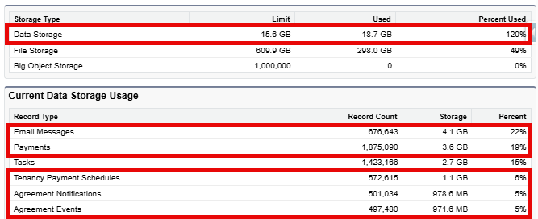
A decision to not investigate the Task object now is due to the savings found elsewhere, and the potential for the business to want to be able to continue to report on and track historic tasks.
In the details below, all numbers are based on records older than 360 days unless explicitly stated.
    - Email Messages
Email Messages vary in size compared to the 2KB standard for other Salesforce records due to attachments, images, amount of text etc. For the findings below, an average email size was calculated as 6.35KB.
The first step was to export emails that were sent from a @graingerplc.co.uk email address in the last 360 days and then to group by subject. The total number of Grainger sent emails from the export was circa 520 000. The top 20 groups are as follows:
Subject |  |  | Subject
Thanks for registering your interes | 94093 |  | Congrats you've been added to a ten | 11972
Thanks for your recent card payment | 60666 |  | : Your tenancy renewal with Graing | 11936
Reminder – please sign your Tenancy | 26012 |  | Your tenancy renewal with Grainger | 11854
Congrats your references have passe | 25792 |  | Your Enquiry - Grainger plc | 9670
We’ve made a change to your tenancy | 24700 |  | Your references have passed and it’ | 8972
Reserve your new Grainger home | 22555 |  | Viewing Booking Updated (EVENTCREAT | 3743
Your references are still underway | 17131 |  | Please sign your Tenancy Agreement | 2781
Congratulations – you’ve just reser | 14211 |  | Filaments - Halogen House Enquiry | 2676
Reminder, your viewing is tomorrow! | 13982 |  | Your tenancy renewal with Grainger | 2634
Please review your Renewal Offer fo | 13264 |  | Clippers - Torrens Apartments Enqui | 2434
 |  |  | Grand Total | 381 078
Table 3 – Top 20 email subjects older than 360 days
The above table represents about 75% of emails from the export and would roughly equate to 2.3GB. These emails all seem to not be ‘operational’ and are rather transactional – sent automatically at a point in time to get the customer onto the next stage in their journey. There does not seem to be any operational benefit in keeping these emails.
    - Payments
Payment records are created as part of the Asperato managed package. Once a payment has been taken successfully there will be the charges reflected in Qube, which is the system of record for all payments. The records in Salesforce enable the collection from the customer.
Payment Stage
Awaiting submission | 393842
Cancelled | 4371
Collected from customer | 552995
Expired | 638214
Failed | 22021
Pending for Cancellation | 4
Submitted for collection | 621
(blank) | 9
Grand Total | 1612077
Table 2 – Payment Records older than 360 days
By deleting the ‘Cancelled’, ‘Expired’, and ‘Failed’ records a saving of circa 1.26GB can be made. Given the nature of these records holding information about payments, anything less than 360 days old, regardless of Payment Stage will be kept.
    - Tenancy Payment Schedules
Based on our analysis, Tenancy Payment Schedules appear to be solely used as a temporary record where a payment schedule is generated to be used in an agreement. Given that the business process has been updated and payment schedules are now no longer included in the agreements a customer signs, these records serve no functional purpose.
Further analysis of the code that creates these records confirms that they are frequently deleted and recreated within the code – i.e. they are not required to be persistent records. This gives confidence that performing a mass delete of old Tenancy Payment Schedule records will not result in any negative impact.
Also to note, this is a different object to the Payment Schedule object that is used by Asperato and is in no way related to the Asperato payment process.
The recommendation here is to delete all Tenancy Payment Schedules older than 360 days, resulting in 823MB of savings.
    - Agreement Notifications
The Agreement Notification is part of the Adobe Sign package. From the investigation completed, these records seem to be created as part of lower-level functionality within the Adobe Sign process when Adobe Sign sends callbacks, primarily to update the Status of an Agreement.
Agreement Status
Cancelled / Declined | 14625
Draft | 19
Expired | 52557
Invalid | 13
Out for Signature | 549
Pre-Send | 1524
Signed | 293453
Waiting for Counter-Signature | 682
(blank) | 2434
Grand Total | 365856
Table 3 – Agreement Notifications older than 360 days
Deleting all the Agreement Notifications older than 360 days results in a saving of 714MB. Given the age of these records, there is very minimal risk that they are involved in an Agreement that is being currently processed.
    - Agreement Events
Agreement Events are also part of the Adobe Sign functionality. They function similarly to an Agreement Notification, however, contain more useful information and are displayed on the Agreement as a chronological audit trail. Given that these records are significantly more useful than the Agreement Notifications none of these records will be deleted.
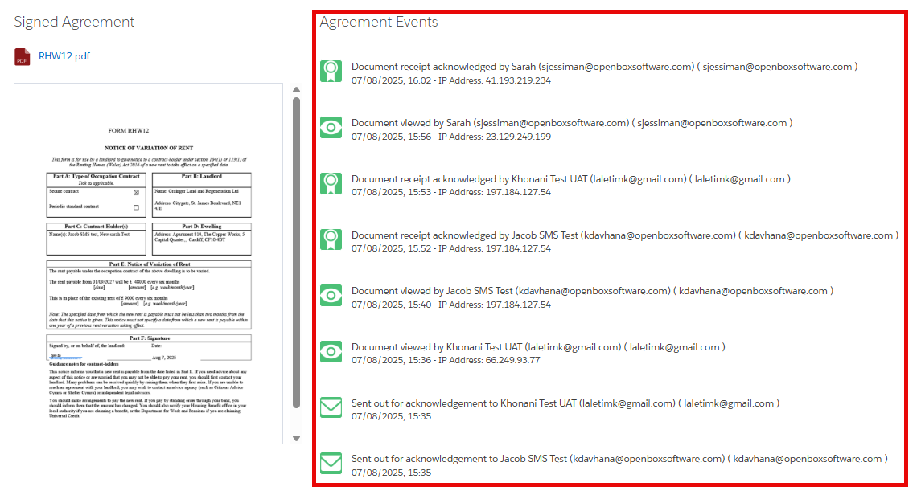

- Recommendations
Out of this consultancy, there are 2 key recommendations that when completed would save upwards of £35 000 (based on costs for extra storage) over the remainder Grainger’s Salesforce contract.
    - Return to Compliance
The first step is to return to compliance by reducing the used Data Storage to below 15.6GB. The above-mentioned deletions total circa 5.1GB, giving a 2GB buffer to the limit.
The strategy to achieve this would be to complete the same deletions in UAT prior to completing them in the PROD environment to ensure that there are no unintended side effects. As part of this UAT exercise, the records will be exported and passed onto the Grainger Data Team as a CSV file. This ensures that the records are backed up, however for all intents and purposes the records are gone and will not be accessible in Salesforce again.
The same strategy would apply to PROD where the records will be exported and passed onto Grainger before completing the deletions.
It is important to note that these CSV files may contain PII data (e.g. emails will contain the email address and names of Grainger tenants/prospects) and Grainger will need to consider GDPR requirements when storing these files.
    - Remaining in Compliance
Following the successful deletion of the excess records, a deeper look into the process for managing and cleaning up data on a regular basis should occur. This can involve multiple stakeholders from Grainger to decide upon business rules that should be followed for each kind of object (with focus given to objects that generate a lot of records like the ones discussed in the report). Unnecessary records that meet the criteria of the decided business rules should then be automatically deleted to ensure that Grainger stay compliant. It is recommended that this deletion process be implemented as a scheduled Apex batch job on Grainger’s Salesforce org, although other options are also feasible – e.g. Azure Data Factory.

- Cost and timelines
- Return to compliance cost
Open Box will provide an agile delivery team to complete the work on a Time and Materials (T&M) basis at a rate of £126/hour.
It is estimated that it will take 10-20 hours to complete the deletion process first in in UAT and then in PROD, resulting in a cost range £1 260 – £2 520.
Given the current change freeze in Production, the recommended timeline is as follows:
- UAT Exports and Deletion week commencing 29th September 2025
- PROD Exports and Deletion week commencing 6th October 2025
It is also suggested to complete PROD deletions outside of core business hours to ensure minimal impact to users.

